Marble Match Up

Subject:  Related Subjects: | Grade Level(s):  Length of Lesson: | Type: Inquiry / Design / Project  Keywords:

Lesson Overview
Students will create a pinball-like game that uses physics concepts to move marbles

Lesson Focus
What is the central question or phenomenon being investigated? What problem are they trying to solve?

Lesson Objective(s) | Create a Game using physics of collisions

Lesson Timing

5 minutes | Introduce the Lesson
30 minutes | ...

Materials | - 20" x 30" foam board shee 3  - Rubber bands 20  - Xacto knives 5  - Marbles 20  - 3 oz paper cups 40  - popsicle sticks 80  - Clothes pin 80  - Gallon Elmer's Glue 1  - –Paint brush 20
Instructor Prep | - Step 1
Related Resources | - List related lessons/ppts etc available from USC or outside, trusted orgs

Lesson Plan

Introduction
Introduce students to the learning goals and make connections to past and present learning experiences. Stimulate interest and prompt students to identify their own questions about the topic. This can link the lesson to real world examples, introduce associated STEM careers, and assess their prior knowledge on the topic.

- Step 1

Procedure
StepNo Step
1 Cut 7”x10” piece of foam board

2 Break 3 popsicle sticks in half

3 On one end of foam board (lengthwise), glue half of mouth of cup to board
4 On the other end of foam board (lengthwise), glue half of mouth of remaining cup to board (see figure 1)
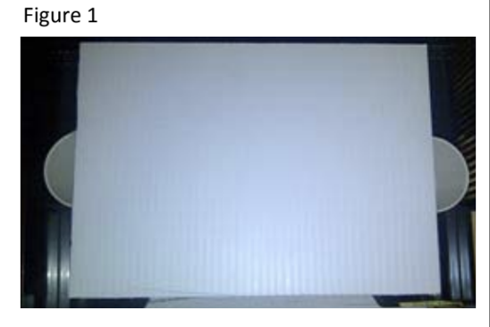
5 Glue one of the coffee stirrer halves to a clothes pin with 1” of the popsicle stick extending beyond the mouth. These are your paddles
6 Repeat for three clothes pins

7 Glue the free side (w/o popsicle stick) of two clothes pins to the end of the foam board (see figure 2):
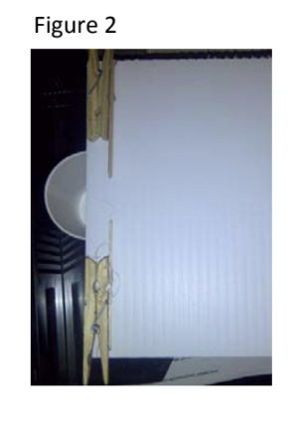
8 --With the free sides flush against the bottom of the board

9 --Facing each other

10 --1" away from each other

11 --With the padle side able to move.

12 Repeat for two other paddles on other side of board (See figure 3)
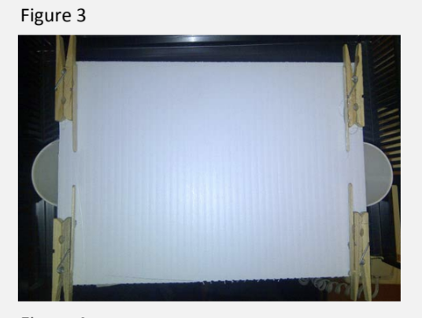

13 Glue two clothes pins together (see figure 4)
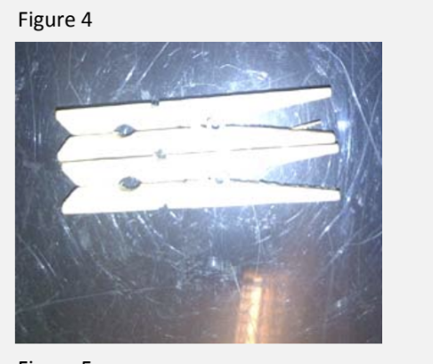
14 Glue one of the popsicle halves to a clothes one side the two glued clothes pins pin with 1/2” of the popsicle stick extending beyond the mouth. This is a flipper
15 Create a second flipper by repeating for the remaining two clothespins.
16 Carefully glue connected part of the two clothes pins of the flippers to the foam board on each side of the board facing each other
(see figure 5):

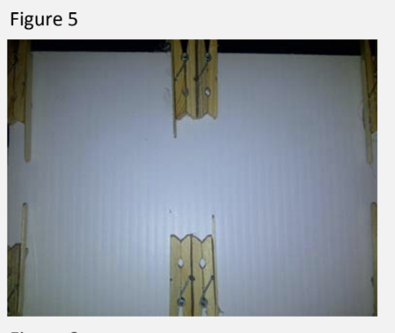

17 --Extended popsicle sticks should be on opposite sides with each one facing a different paddle
18 --About 4" from the paddles
19 --leave the unconnected parts free to move
20 Let the glue dry (see figure 6)
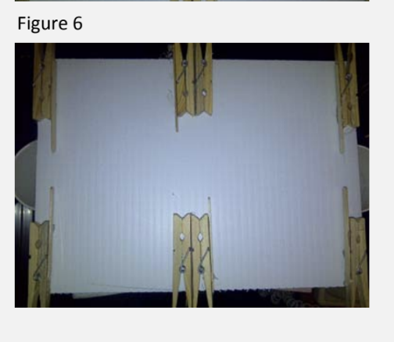
21 Extend a rubber band from the paddle on one end to the paddle on the other end (see figure 7)
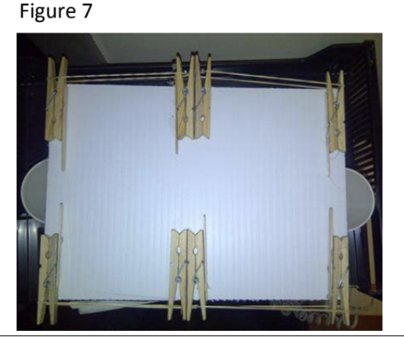

Wrap-up
End the lesson with some final discussions about what students designed/discovered. Connect their activity back to the focus question/problem, real world examples, and STEM careers.

Also include notes about any special cleanup considerations

Lesson Background for Teachers

Suggested Real-World STEM Connections
- List possible related Role Models in STEM (with details and links to more reading). Give suggestions for examples of scientists/engineers who are from underrepresented groups in STEM in related careers.
- List related real-world engineering problems and examples

Lesson Variations and Options
Include descriptions of alternative methods or ways to present things.

Explanation
Pinball machines date back to the 1600s. Foosball (table football) dates back to the early 1900s. Marble match up is like a 2 person pinball machine combined with Foosball. It uses clothespins and marbles instead offlippers and players.
The clothespins contain springs that forces it closed after being opened. The force of the spring can be used to propel the marble, stop it's motion or change its direction. A marble on the board would roll and eventually come to a stop. However, we can alter the path using elastic collisions (when things hit each other and their shapes aren't
changed) with the paddles, flipper or rubber band sides of the board

Key Concepts and Vocabulary
- Word 1: Grade Appropriate Definition
- Word 2: Grade Appropriate Definition

Safety Notes
- Safety instruction

